MISSING PERSON AND WANTED CRIMINAL DATABASE SYSTEM
Jamilla Issah *, Student;
Mr. Richard Phiri *, Supervisor;

ABSTRACT
The absence of a centralized system for reporting and tracking missing persons and wanted criminals poses significant challenges for law enforcement and the public. This web-based application addresses these challenges by enabling both police and citizens to report missing persons with details such as photos and last known locations. Law enforcement can also flag wanted criminals, allowing citizens to submit anonymous tips that aid investigations. Email notifications keep users informed about new cases and important developments, ensuring timely dissemination of information. By leveraging technology for real-time reporting and tracking, this system enhances public safety, streamlines police efforts, and increases the chances of reuniting missing individuals with their families.

- INTRODUCTION
The rapid increase in reported cases of missing persons and wanted criminals has become a pressing issue for both government and society. In Malawi and other developing countries, the process of locating missing individuals or apprehending fugitives is typically slowed by inefficient manual record-keeping systems and lack of coordination between police departments and the public. These traditional methods, including posters, social media posts, and local announcements, often fail to reach a wide audience or provide timely updates. The inefficiency results in delayed responses, reduced recovery rates, and increased risk to vulnerable individuals.
This research introduces a centralized web-based platform designed to bridge the communication gap between law enforcement agencies and the public. The proposed system allows citizens to report missing persons and wanted criminals through an online portal, upload photographs, and provide last-known details. The police can then verify, classify, and update reports in real time, making the process transparent and faster. In addition, the inclusion of email notifications ensures that relevant authorities and families receive immediate updates on reported cases.
A critical innovation of this project is the integration of a machine learning module using the Random Forest algorithm, which analyzes past cases and predicts potential connections between reports. This intelligent feature assists officers in identifying trends or recurring patterns, improving investigation accuracy. Overall, the system contributes to enhancing public safety, improving law enforcement efficiency, and establishing a digital foundation for crime prevention and social security in Malawi.
- RELATED WORKS
The study of missing persons and criminal tracking has been widely explored in academic and law enforcement research. Several technological advancements, including online databases and predictive analytics, have been implemented to improve case resolution.
Miethe, T. D., Wetherell, K. T. E., & Regoeczi, W. C. (2023). Missing Persons: A National Survey Approach Assessing the Predictors of Case Outcomes. This study examines the key factors influencing the outcomes of missing person cases, focusing on demographic characteristics and the effectiveness of search efforts. The findings highlight the importance of coordinated law enforcement strategies and public engagement in locating missing individuals.
Phoenix, J., & Francis, B. J. (2023). Police Risk Assessment and Case Outcomes in Missing Person Investigations. The research investigates how law enforcement classifies missing persons as high-risk and examines the impact of age, sex, and situational factors on case resolutions. It underscores the importance of early intervention strategies in improving case outcomes.
Richards, Y., McClish, M., & Keatley, D. (2023). Finding the Missing: Using Statement Analysis to Assist in Missing Persons Cases. This paper explores how linguistic analysis techniques can be used to distinguish truthful statements from deceptive ones in missing person cases. It highlights the potential of forensic linguistics in aiding investigative processes.
Papesh, M. H., Cash, D. K., Pinto, J. D. G., & Lomba, S. V. (2024). Spotting Missing or Wanted People: Racial Biases in Prospective Person Memory. The study analyzes racial biases in recognizing missing and wanted individuals, revealing disparities in identification accuracy across different racial groups. The findings suggest the need for bias-aware training programs in law enforcement.
McKie, R. (2024). The Nameless Dead: Scientists Hunt for Identities of Thousands Who Tried to Reach Europe. This article discusses the challenges of identifying deceased migrants who attempted to reach Europe, highlighting new scientific methods for forensic identification. It explores the role of DNA matching, biometric databases, and international collaboration in resolving unidentified cases
- METHODOLOGY
The system was developed using the Agile Software Development methodology, which focuses on iterative design, user feedback, and continuous improvement. The project was divided into several development phases, including requirements gathering, system design, implementation, testing, and deployment.
During the requirement analysis phase, detailed interviews and observations were conducted with police officers and community representatives to understand the shortcomings of current systems. The identified needs included faster report submission, real-time tracking, and a user-friendly interface accessible to both citizens and law enforcement.
The system design phase involved creating architectural diagrams, data flow diagrams (DFD), and use case models to outline the flow of information. The system adopts a three-tier architecture consisting of the presentation layer, application layer, and data layer. The presentation layer handles user interfaces built with HTML, CSS, JavaScript, and Bootstrap. The application layer uses PHP to process business logic and enforce security mechanisms, while the data layer uses MySQL to store user information, reports, and notifications.
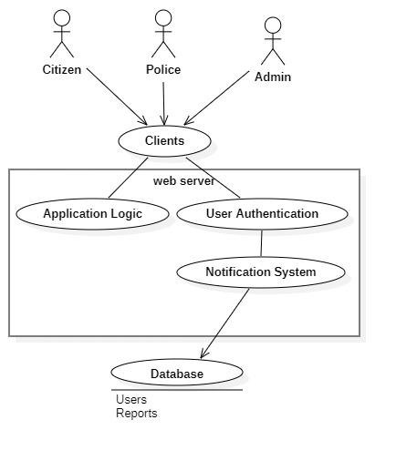
Figure 1 System Architecture
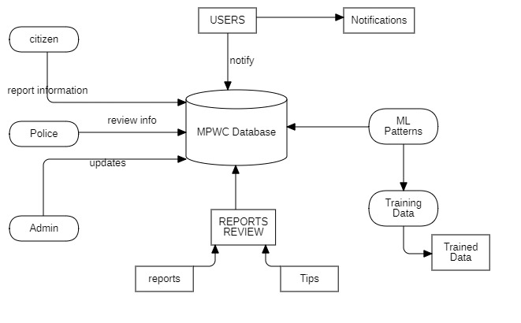
Figure 2 Data Flow Diagram
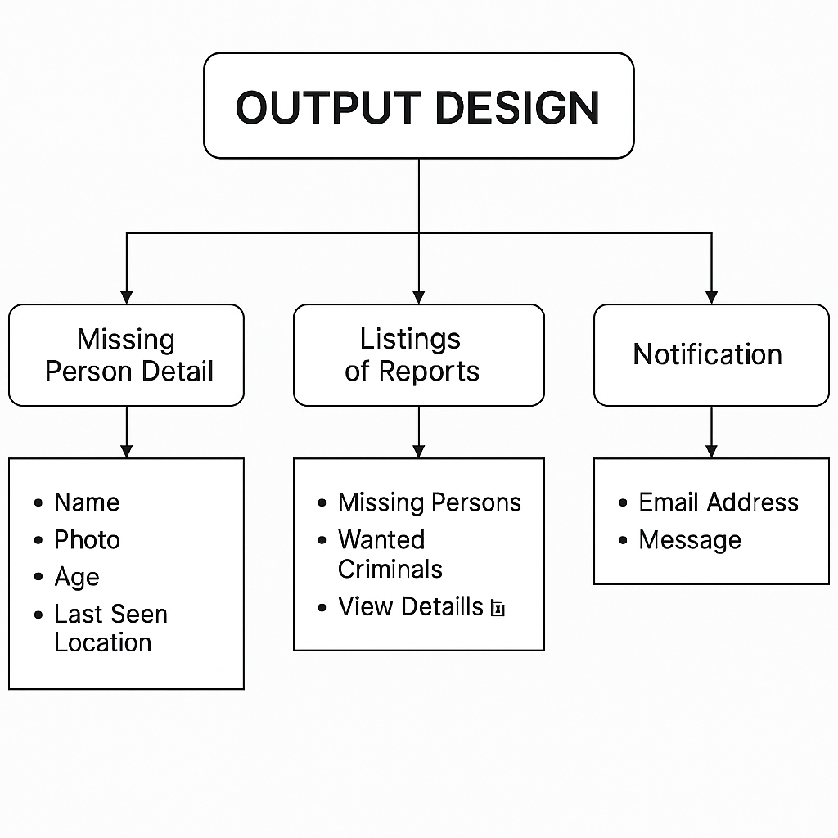
Figure 3 Output Design Diagram
In the implementation phase, modules such as user registration, report submission, anonymous tips, and police management were developed. The testing phase applied unit, integration, and user acceptance testing (UAT) to ensure system reliability and efficiency.
- ALGORITHM
The system incorporates the Random Forest algorithm, a supervised machine learning model widely used for classification and prediction tasks. The algorithm enhances the system’s intelligence by identifying possible matches between new and existing missing person reports or criminal profiles.
The Random Forest model operates by constructing multiple decision trees using different subsets of data and features. Each tree independently predicts whether two cases are likely related, and the final decision is based on the majority vote of all trees. Input features such as age, gender, location, date of disappearance, and case description are analyzed to detect potential similarities. This predictive matching assists police in recognizing linked cases more quickly than manual comparison methods.
By integrating this algorithm, the system not only acts as a database but also as a decision-support tool, allowing law enforcement agencies to make informed judgments, allocate resources effectively, and identify patterns of criminal or disappearance activity.
- SCREENSHOTS
The system interface was designed to be simple, intuitive, and responsive. The Landing Page introduces users to the system and provides options to log in or register. The Login Page authenticates users based on roles citizen, police or administrator and directs them to their respective dashboards.
Registered users access the User Dashboard, where they can view public notices, report missing persons, and submit information about wanted criminals. The Report Submission Page allows uploading photographs, entering detailed descriptions, and specifying the last known location. For law enforcement officers, the Police Dashboard provides tools for verifying submitted cases, updating statuses, and managing wanted lists.

Figure 4 User Dashboard
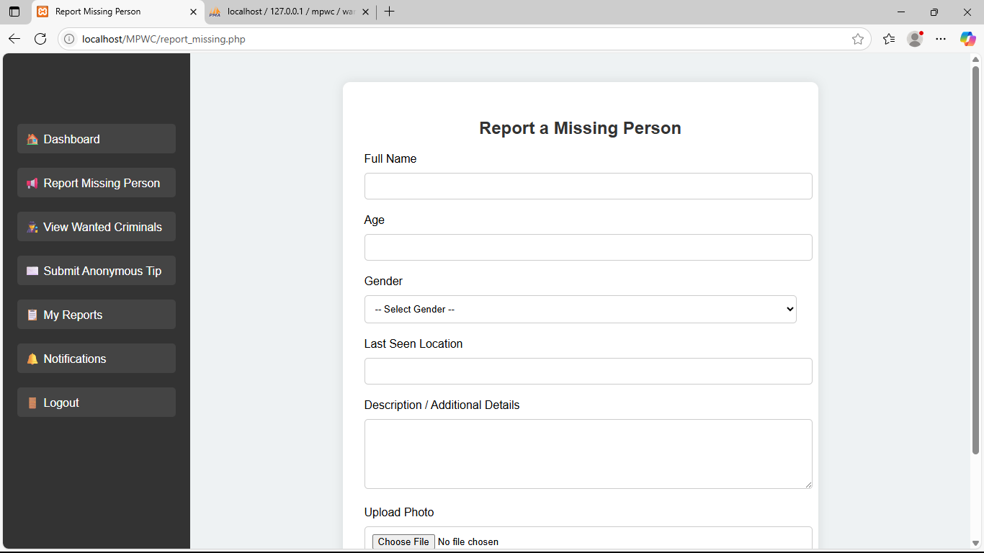
Figure 5 User Reporting Page


Figure 6 Police Dashboard

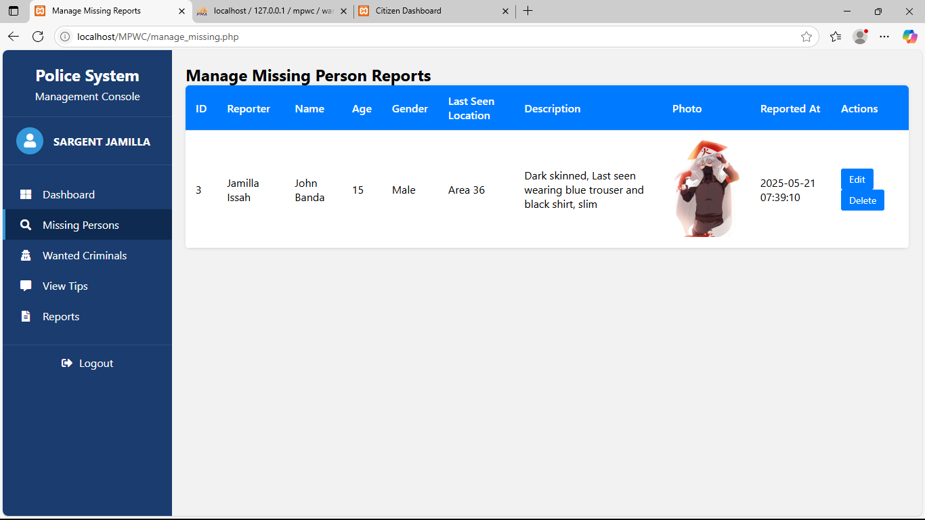
Figure 7 Manage Missing People page
- RESULTS AND DISCUSSION
Comprehensive testing was conducted to validate the system’s functionality, usability, and security. The test plan included unit tests for individual modules, integration tests to confirm module interaction, and system testing to ensure the software meets all user requirements.
- The test results demonstrated a 100% success rate across all major functions, including user registration, login, report submission, anonymous tips, email notifications, and admin management. The system performance was excellent, with fast response times and accurate search results. Users rated the interface as clear and easy to navigate.
- The integration of the Random Forest algorithm significantly improved the detection of potential matches between cases. During evaluation, the predictive model achieved an approximate accuracy rate of 80% compared to manual identification. This confirms the system’s potential to aid in investigative efficiency. Furthermore, the automated email notification feature successfully delivered alerts within seconds of report updates, improving communication between citizens and authorities.
- From a security perspective, the system implements password hashing, session control, and input validation to prevent unauthorized access and data manipulation. The feedback collected from pilot testing with police officers indicated that the system would save significant time and improve coordination across departments.
- CONCLUSION
The Missing Person and Wanted Criminal Database System provides a modern and efficient digital solution for addressing one of the most persistent societal problems — locating missing persons and tracking wanted criminals. By leveraging web technologies and machine learning, the system offers a centralized platform that connects citizens with law enforcement agencies in real time. It promotes transparency, accountability, and timely communication, thereby improving the rate of successful investigations.
The project successfully met its objectives of developing a secure, user-friendly, and intelligent platform. It introduced innovations such as automated notifications, role-based access control, and data-driven decision support. The integration of the Random Forest algorithm proved highly beneficial in identifying potential matches and accelerating investigations.
For future improvements, the system can be enhanced with SMS notifications, mobile app integration, and AI-powered facial recognition to strengthen identification accuracy. Furthermore, incorporating a data analytics dashboard could provide visual insights into case trends, helping police agencies allocate resources strategically.
In conclusion, this project demonstrates how digital transformation can enhance public safety and support law enforcement efforts in Malawi and beyond. The implementation of such systems could revolutionize how cases are managed, ensuring that every missing person and every wanted criminal is effectively traced through technology-driven intelligence.

REFERENCES
- Han, J., Kamber, M., & Pei, J. (2011). Data Mining: Concepts and Techniques (3rd ed.). Elsevier.
- Hargittai, E. (2005). Survey Measures of Web-Oriented Digital Literacy. Social Science Computer Review, 23(3), 371–379.
- INTERPOL. (2023). Yellow and Red Notices for Missing and Wanted Persons. Retrieved from: https://www.interpol.int
- Laudon, K. C., & Laudon, J. P. (2020). Management Information Systems: Managing the Digital Firm (16th ed.). Pearson Education.
- McKie, R. (2024). The Nameless Dead: Scientists Hunt for Identities of Thousands Who Tried to Reach Europe. The Guardian Science.
- Miethe, T. D., Wetherell, K. T. E., & Regoeczi, W. C. (2023). Missing Persons: A National Survey Approach Assessing the Predictors of Case Outcomes. Journal of Criminal Justice.
- National Crime Agency. (2022). Missing Persons Data Report 2021-2022. Retrieved from: https://www.nca.gov.uk
- Papesh, M. H., Cash, D. K., Pinto, J. D. G., & Lomba, S. V. (2024). Spotting Missing or Wanted People: Racial Biases in Prospective Person Memory. Psychology, Crime & Law.
- Phoenix, J., & Francis, B. J. (2023). Police Risk Assessment and Case Outcomes in Missing Person Investigations. Policing and Society.
- Richards, Y., McClish, M., & Keatley, D. (2023). Finding the Missing: Using Statement Analysis to Assist in Missing Persons Cases. Forensic Linguistics Review.
- Witten, I. H., Frank, E., & Hall, M. A. (2016). Data Mining: Practical Machine Learning Tools and Techniques (4th ed.). Morgan Kaufmann.
- World Health Organization. (2022). Guidelines on Personal Data Protection in Health and Safety Systems. WHO Publications.

